Project Development Phase
Model Performance Test

Date | 30 August 2026
Team ID
Project Name | An employee requests installation of licensed software through the Service Catalog
Maximum Marks

Model Performance Testing:

S.No. | Parameter | Values | Screenshot
 | System Summary | ServiceNow-based Software Installation Request system that allows employees to request licensed software through the Service Catalog and automates approval, fulfillment, tracking, and exception handling. | 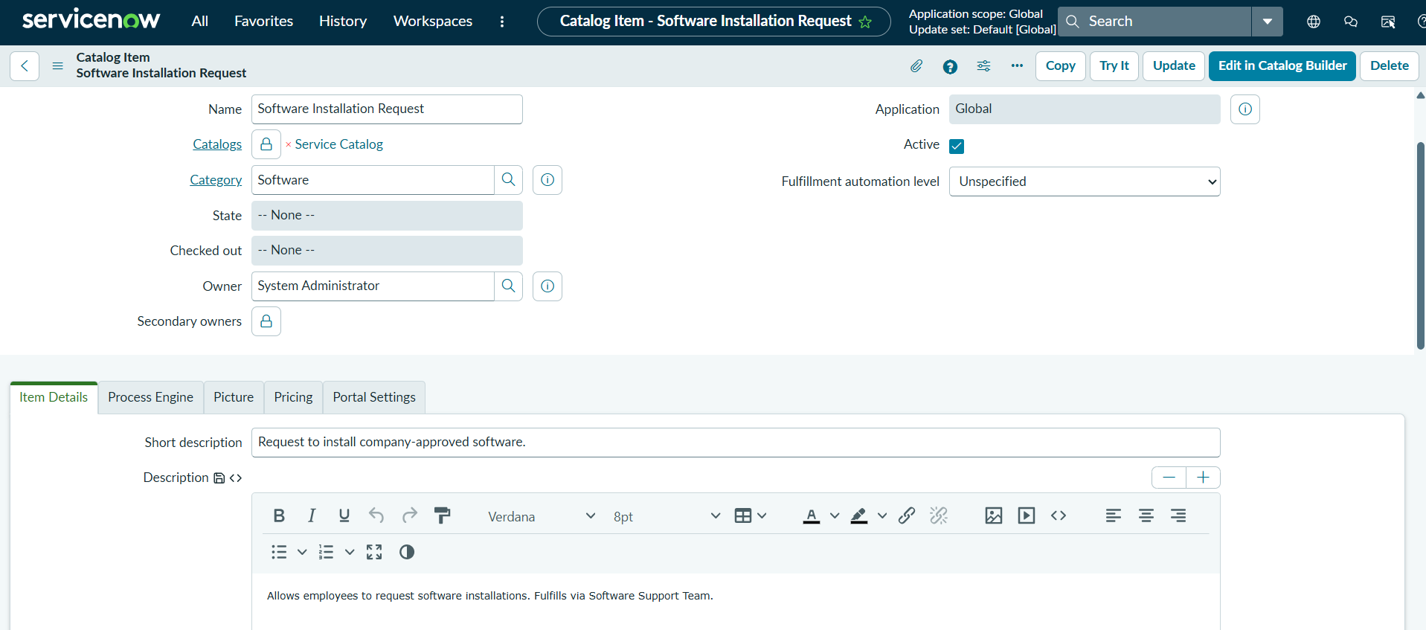
 | Request Submission Performance | Successful – Employee can enter the required software details and submit the request successfully. | 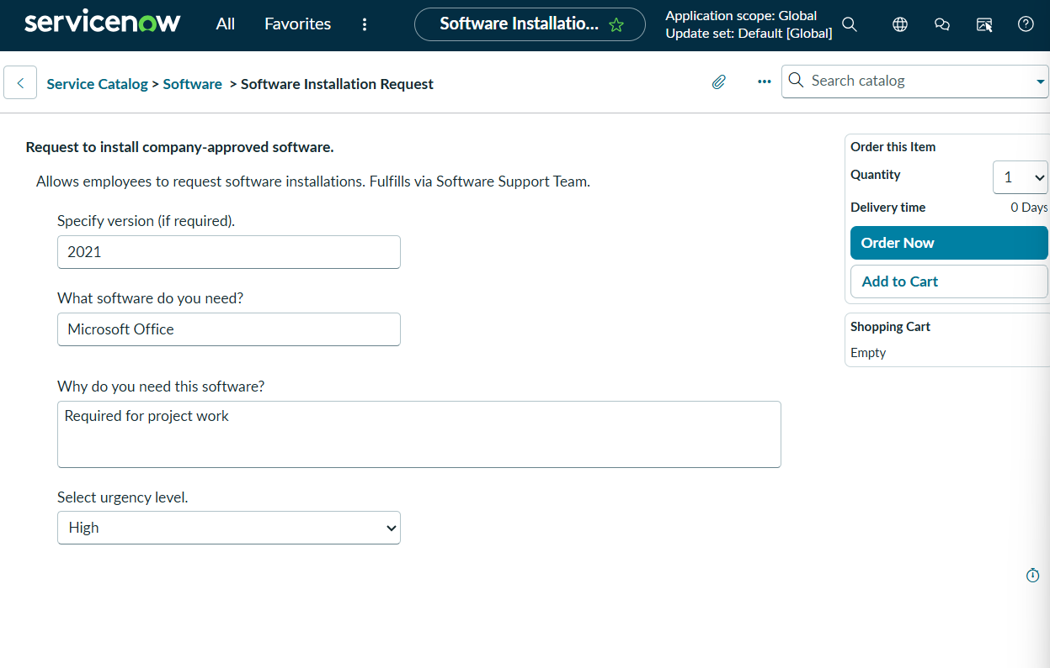
3. | Request Creation | Successful – ServiceNow generates the Request (REQ) and Requested Item (RITM) records after submission. | 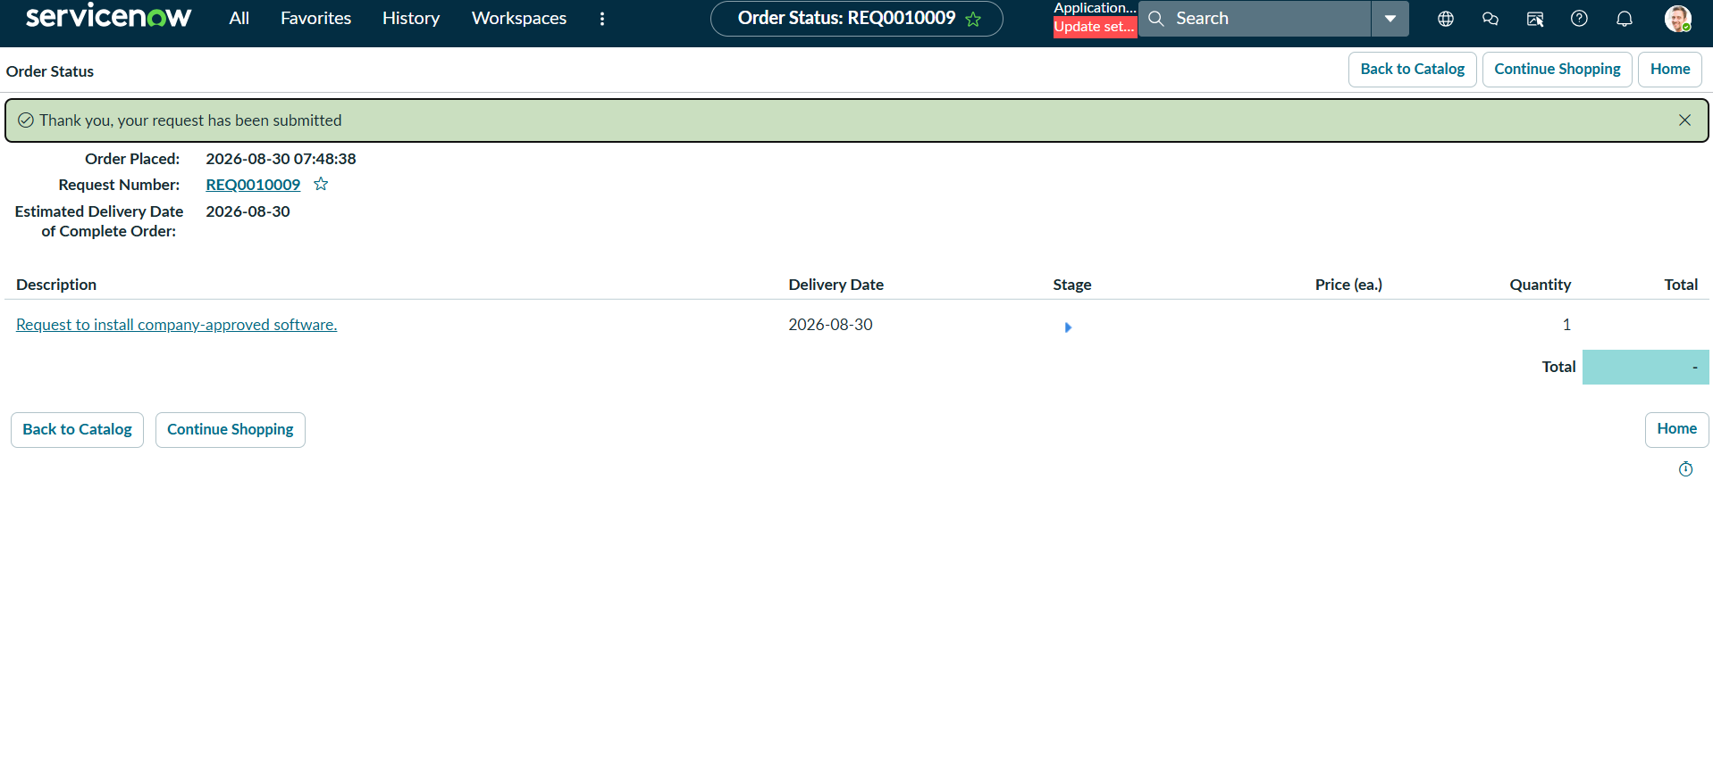
4. | Approval Automation | Successful – Submitted request is routed to the configured approver for approval. | 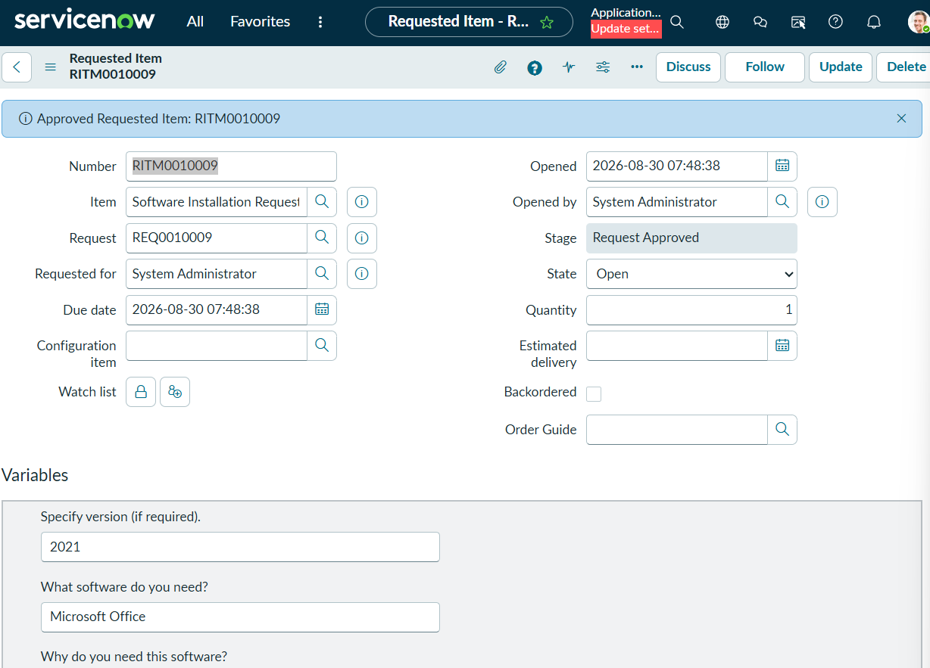
5. | Task Creation | Successful – After approval, a Catalog Task (SCTASK) is automatically created. | 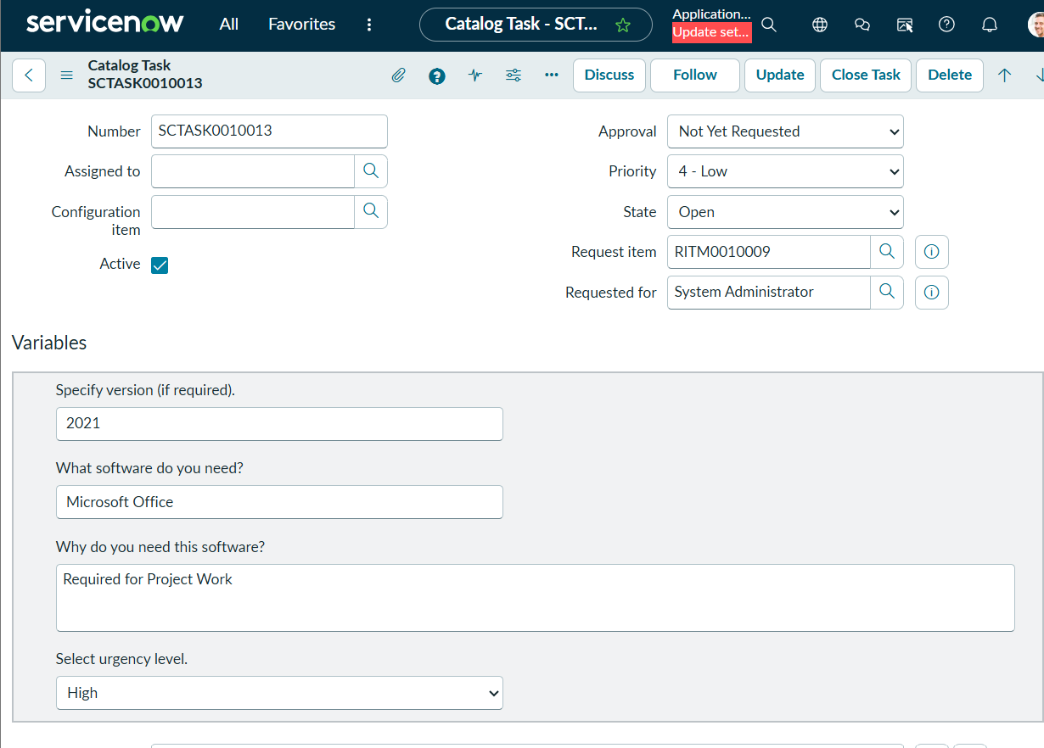
6. | Task Assignment | Successful – Catalog Task is assigned to the Software Support team. | 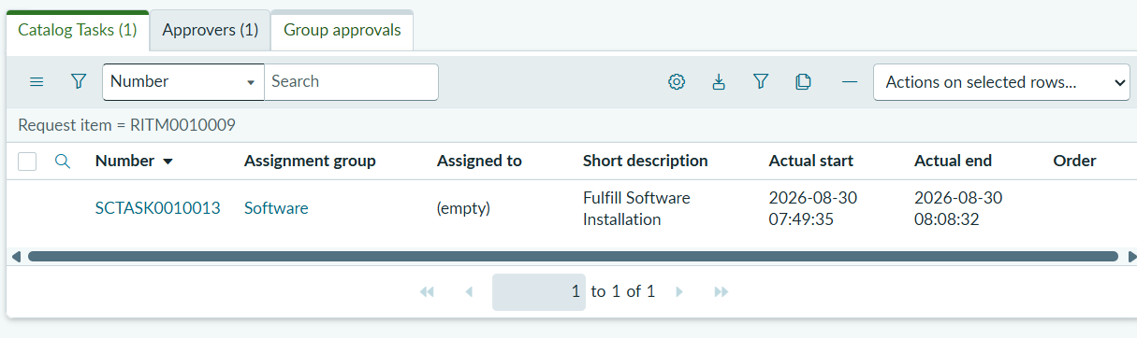
7. | Task State Management | Successful – Task state can be updated through the fulfillment process, such as Open → Work in Progress → Completed. | 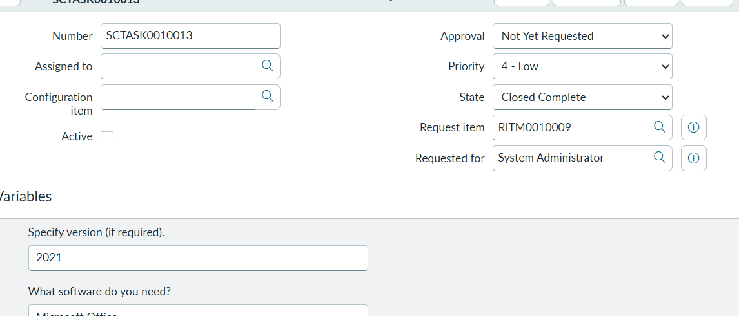
8.. | Overall System Performance | Successful – The complete software request lifecycle executes according to the configured process without functional errors. | 